"Министерство науки и высшего образования Российской Федерации

Федеральное государственное бюджетное образовательное учреждение

высшего образования

«Сибирский государственный автомобильно-дорожный университет (СибАДИ)»

Факультет Информационные системы в управлении

Направление 10.03.01Информационная безопасность

Кафедра Информационная безопасность

**ОТЧЕТ**

**по лабораторным работам**

по дисциплине «Безопасность вычислительных сетей»

Выполнила студент группы БИб-21Э1 Парфёнов Александр Романович

Преподаватель

_________________А. Д. Панков

«___» ______________ 2023г

Омск 2023

Задание 1 Парсинг сайта

Код

from selenium import webdriver  
from selenium.webdriver.common.by import By  
from selenium.webdriver.chrome.service import Service  
from webdriver_manager.chrome import ChromeDriverManager  
import pandas as pd  
  
  
driver = webdriver.Chrome(service=Service(ChromeDriverManager().install()))  
driver.get('https://iotvega.com/product')  
  
productElements = driver.find_elements(By.CLASS_NAME, 'product-name')  
priceElements = driver.find_elements(By.CLASS_NAME, 'price_item')  
  
productNames = list(map(lambda element:element.text, productElements))  
productPrices = list(map(lambda element:element.text, priceElements))  
  
driver.quit()  
  
df = pd.DataFrame([productNames, productPrices])  
df.to_excel(excel_writer= "product.xlsx")

Результат

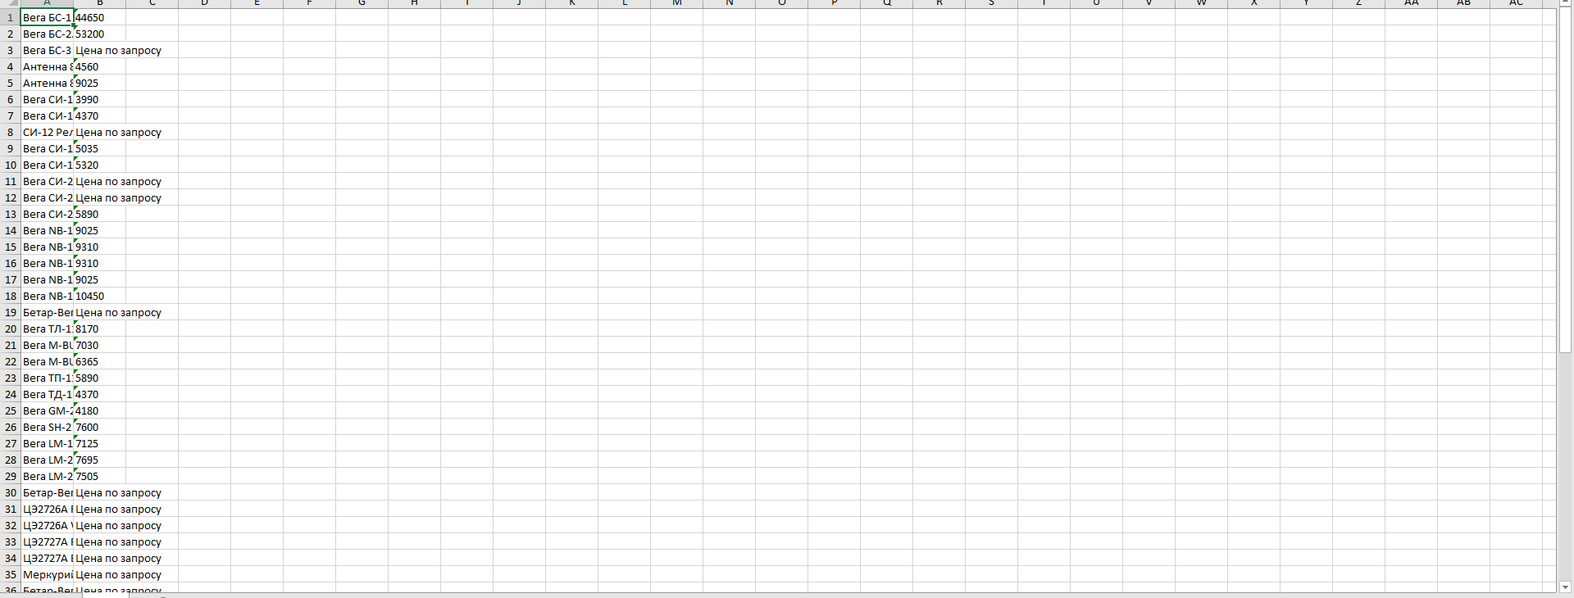

Задание 2 Подключение по ssh

Код

import time  
from pywinauto.application import Application  
import keyboard  
  
app = Application().start("C:\Program Files\PuTTY\putty.exe -ssh sashaparfe@tty.sdf.org")  
  
time.sleep(5)  
keyboard.write("5UzmZqKm7mapig")  
  
  
time.sleep(5)  
keyboard.send('enter')  
time.sleep(1)  
keyboard.send('enter')  
time.sleep(1)  
keyboard.send('enter')  
time.sleep(1)  
keyboard.send('enter')  
time.sleep(1)  
keyboard.send('enter')  
time.sleep(1)  
keyboard.send('enter')  
time.sleep(1)  
keyboard.send('enter')  
time.sleep(10)

Результат

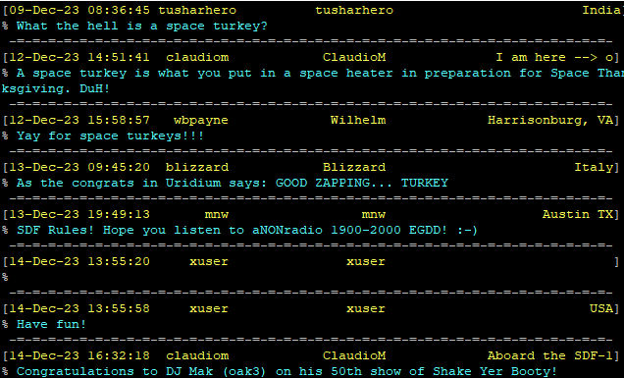

Задание 3 Kali Linux

Задание 4

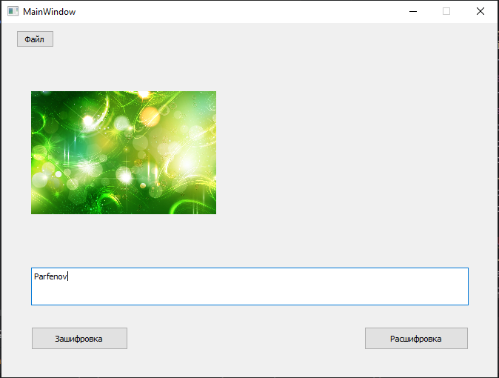

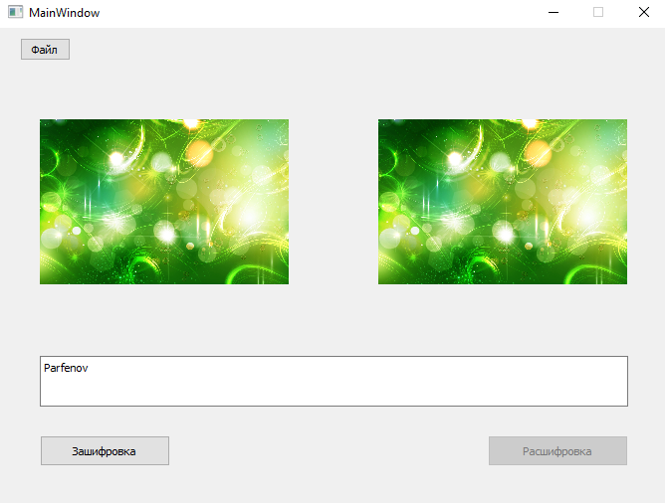

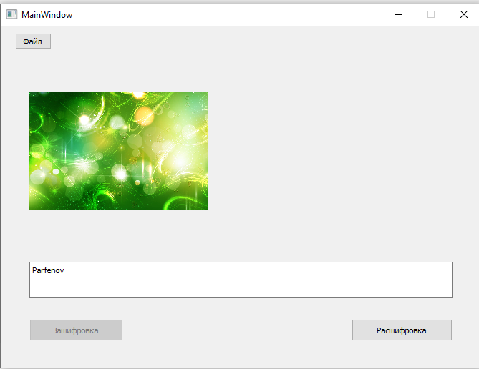

Код main.py

from PyQt5 import QtWidgets  
from untitled import Ui_MainWindow  
from PyQt5.QtGui import QPixmap  
import sys  
import Kod  
  
class mywindow(QtWidgets.QMainWindow):  
 def __init__(self, picture_path = None):  
 self.picture_path = picture_path  
 super(mywindow, self).__init__()  
 self.ui = Ui_MainWindow()  
 self.ui.setupUi(self)  
 self.ui.pushButton_3.clicked.connect(self.browse_folder)  
 self.ui.pushButton.clicked.connect(self.encrypt)  
 self.ui.pushButton_2.clicked.connect(self.decrypt)  
 self.ui.textEdit.setEnabled(False)  
 self.ui.pushButton.setEnabled(False)  
 self.ui.pushButton_2.setEnabled(False)  
 def browse_folder(self):  
 self.ui.textEdit.clear()  
 self.ui.label.clear()  
 self.ui.label_2.clear()  
 self.ui.textEdit.setEnabled(True)  
 self.ui.pushButton.setEnabled(True)  
 self.ui.pushButton_2.setEnabled(True)  
 self.picture_path = QtWidgets.QFileDialog.getOpenFileName(self, "Выберите файл")  
 pixmap = QPixmap(self.picture_path[0])  
 pixmap = pixmap.scaled(250, 250, aspectRatioMode= 1)  
 self.ui.label.setPixmap(pixmap)  
 def encrypt(self):  
 self.ui.pushButton_2.setEnabled(False)  
 self.save, _ = QtWidgets.QFileDialog.getSaveFileName(self, "Выберете куда сохранить файл", '.', 'Изображение (*.png)')  
 self.im = Kod.cod(self.picture_path[0], self.ui.textEdit.toPlainText(), self.save)  
 pixmap = QPixmap(self.im)  
 pixmap = pixmap.scaled(250, 250, aspectRatioMode= 1)  
 self.ui.label_2.setPixmap(pixmap)  
 def decrypt(self):  
 self.ui.pushButton.setEnabled(False)  
 self.txt = Kod.decod(self.picture_path[0])  
 self.ui.textEdit.setPlainText(self.txt)  
def main():  
 app = QtWidgets.QApplication(sys.argv)  
 window = mywindow()  
 window.show()  
 app.exec_()  
  
if __name__ == '__main__':  
 main()

Код Kod.py

from PIL import Image  
  
def cod(File, Text, Save):  
 file = (File)  
  
 im = Image.open(file).convert('RGBA')  
 pix = im.load()  
 w, h = im.size  
  
 nan = str(Text)  
  
 if h < 255:  
 if len(nan) > h:  
 return 0  
 elif len(nan) > 255:  
 return 0  
  
 r, g, b, a = pix[0, 0]  
 pix[0, 0] = len(nan), g, b, a  
  
 for i in range(len(nan)):  
 r, g, b, a = pix[0, i+1]  
 pix[0, i+1] = ord(nan[i]), g, b, a  
  
 im.save(Save)  
  
 return Save  
  
def decod(File):  
 file2 = (File)  
  
 im = Image.open(file2).convert('RGBA')  
 pix = im.load()  
  
 name = ''  
 r, g, b, a = pix[0, 0]  
  
 for j in range(int(r)):  
 r1, g1, b1, a1 = pix[0, j+1]  
 name += chr(r1)  
  
 return name

Код Untitled.py

# -*- coding: utf-8 -*-  
  
# Form implementation generated from reading ui file 'untitled.ui'  
#  
# Created by: PyQt5 UI code generator 5.15.9  
#  
# WARNING: Any manual changes made to this file will be lost when pyuic5 is  
# run again. Do not edit this file unless you know what you are doing.  
  
  
from PyQt5 import QtCore, QtGui, QtWidgets  
  
  
class Ui_MainWindow(object):  
 def setupUi(self, MainWindow):  
 MainWindow.setObjectName("MainWindow")  
 MainWindow.resize(670, 478)  
 MainWindow.setMinimumSize(QtCore.QSize(670, 478))  
 MainWindow.setMaximumSize(QtCore.QSize(670, 478))  
 self.centralwidget = QtWidgets.QWidget(MainWindow)  
 self.centralwidget.setObjectName("centralwidget")  
 self.pushButton = QtWidgets.QPushButton(self.centralwidget)  
 self.pushButton.setGeometry(QtCore.QRect(40, 410, 131, 31))  
 self.pushButton.setObjectName("pushButton")  
 self.pushButton_2 = QtWidgets.QPushButton(self.centralwidget)  
 self.pushButton_2.setGeometry(QtCore.QRect(490, 410, 141, 31))  
 self.pushButton_2.setObjectName("pushButton_2")  
 self.pushButton_3 = QtWidgets.QPushButton(self.centralwidget)  
 self.pushButton_3.setGeometry(QtCore.QRect(20, 10, 51, 23))  
 self.pushButton_3.setObjectName("pushButton_3")  
 self.textEdit = QtWidgets.QTextEdit(self.centralwidget)  
 self.textEdit.setGeometry(QtCore.QRect(40, 330, 591, 51))  
 self.textEdit.setObjectName("textEdit")  
 self.label = QtWidgets.QLabel(self.centralwidget)  
 self.label.setGeometry(QtCore.QRect(40, 50, 250, 250))  
 self.label.setText("")  
 self.label.setObjectName("label")  
 self.label_2 = QtWidgets.QLabel(self.centralwidget)  
 self.label_2.setGeometry(QtCore.QRect(380, 50, 250, 250))  
 self.label_2.setText("")  
 self.label_2.setObjectName("label_2")  
 MainWindow.setCentralWidget(self.centralwidget)  
  
 self.retranslateUi(MainWindow)  
 QtCore.QMetaObject.connectSlotsByName(MainWindow)  
  
 def retranslateUi(self, MainWindow):  
 _translate = QtCore.QCoreApplication.translate  
 MainWindow.setWindowTitle(_translate("MainWindow", "MainWindow"))  
 self.pushButton.setText(_translate("MainWindow", "Зашифровка"))  
 self.pushButton_2.setText(_translate("MainWindow", "Расшифровка"))  
 self.pushButton_3.setText(_translate("MainWindow", "Файл"))